**Step 1 – Create and run new Angular Application**

 Navigate to any local folder, Open visual studio code and open terminal window

Check Angular CLI version

>ng version

If not latest version or not installed

>npm install -g @angular/cli@10.0.1

CLI command to create new application

>ng new angularLab

Run the application

>ng serve -open

**Step 2 – Initial setup of Angular Material, Angular CDK and Animations**

Install angular material

>ng add @angular/material

It prompts for theme selection, select following options

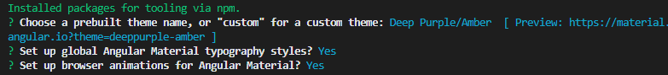

 Adds BrowserAnimationsModule in app module

**Step 3 - Creating Material module**

Creating new module and adding the reference in App Module

>ng g module material -m App

 Though can be imported in app.module.ts for better architecture add new module and refer

 In the material.module.ts, add the highlighted code -

 Add export section, create materials array, import required controls

import { NgModule } from '@angular/core';

import { MatButtonModule } from '@angular/material/button';

const materials = [

    MatButtonModule

  ]

@NgModule({

  declarations: [],

  imports: [

    materials

  ],

  exports: [

    materials

  ]

})

export class MaterialModule { }

**Step 4 – Clean up default content in App Component**

Goto – ‘src\app\app.component.html’ – and remove default template content and just add

<h1> First App Component </h1>

With this, the initial application setup is ready.

**Step 5 – Check out CLI help commands for awareness**

>ng help

>ng [command name] --help

>ng generate --help

>ng generate component --help

>ng g c --help